Wood burning (Pyrography) with Louise Reilly Cost $30.00

April 22, Saturday morning, 9:00 – 12:00. Beginner to intermediate class.

The topics will be a choice of a human character - "The Tree Troll" or "The Inventor" or an old building called "Mr. Stratton's Outhouse". The media will be a basswood plaque. Participants may bring their own burners and pyrography pens. There will be a limited number of burner kits available on loan from Prairie Canada - reserve along with your registration. Materials are supplied. Additional details will follow after registration.
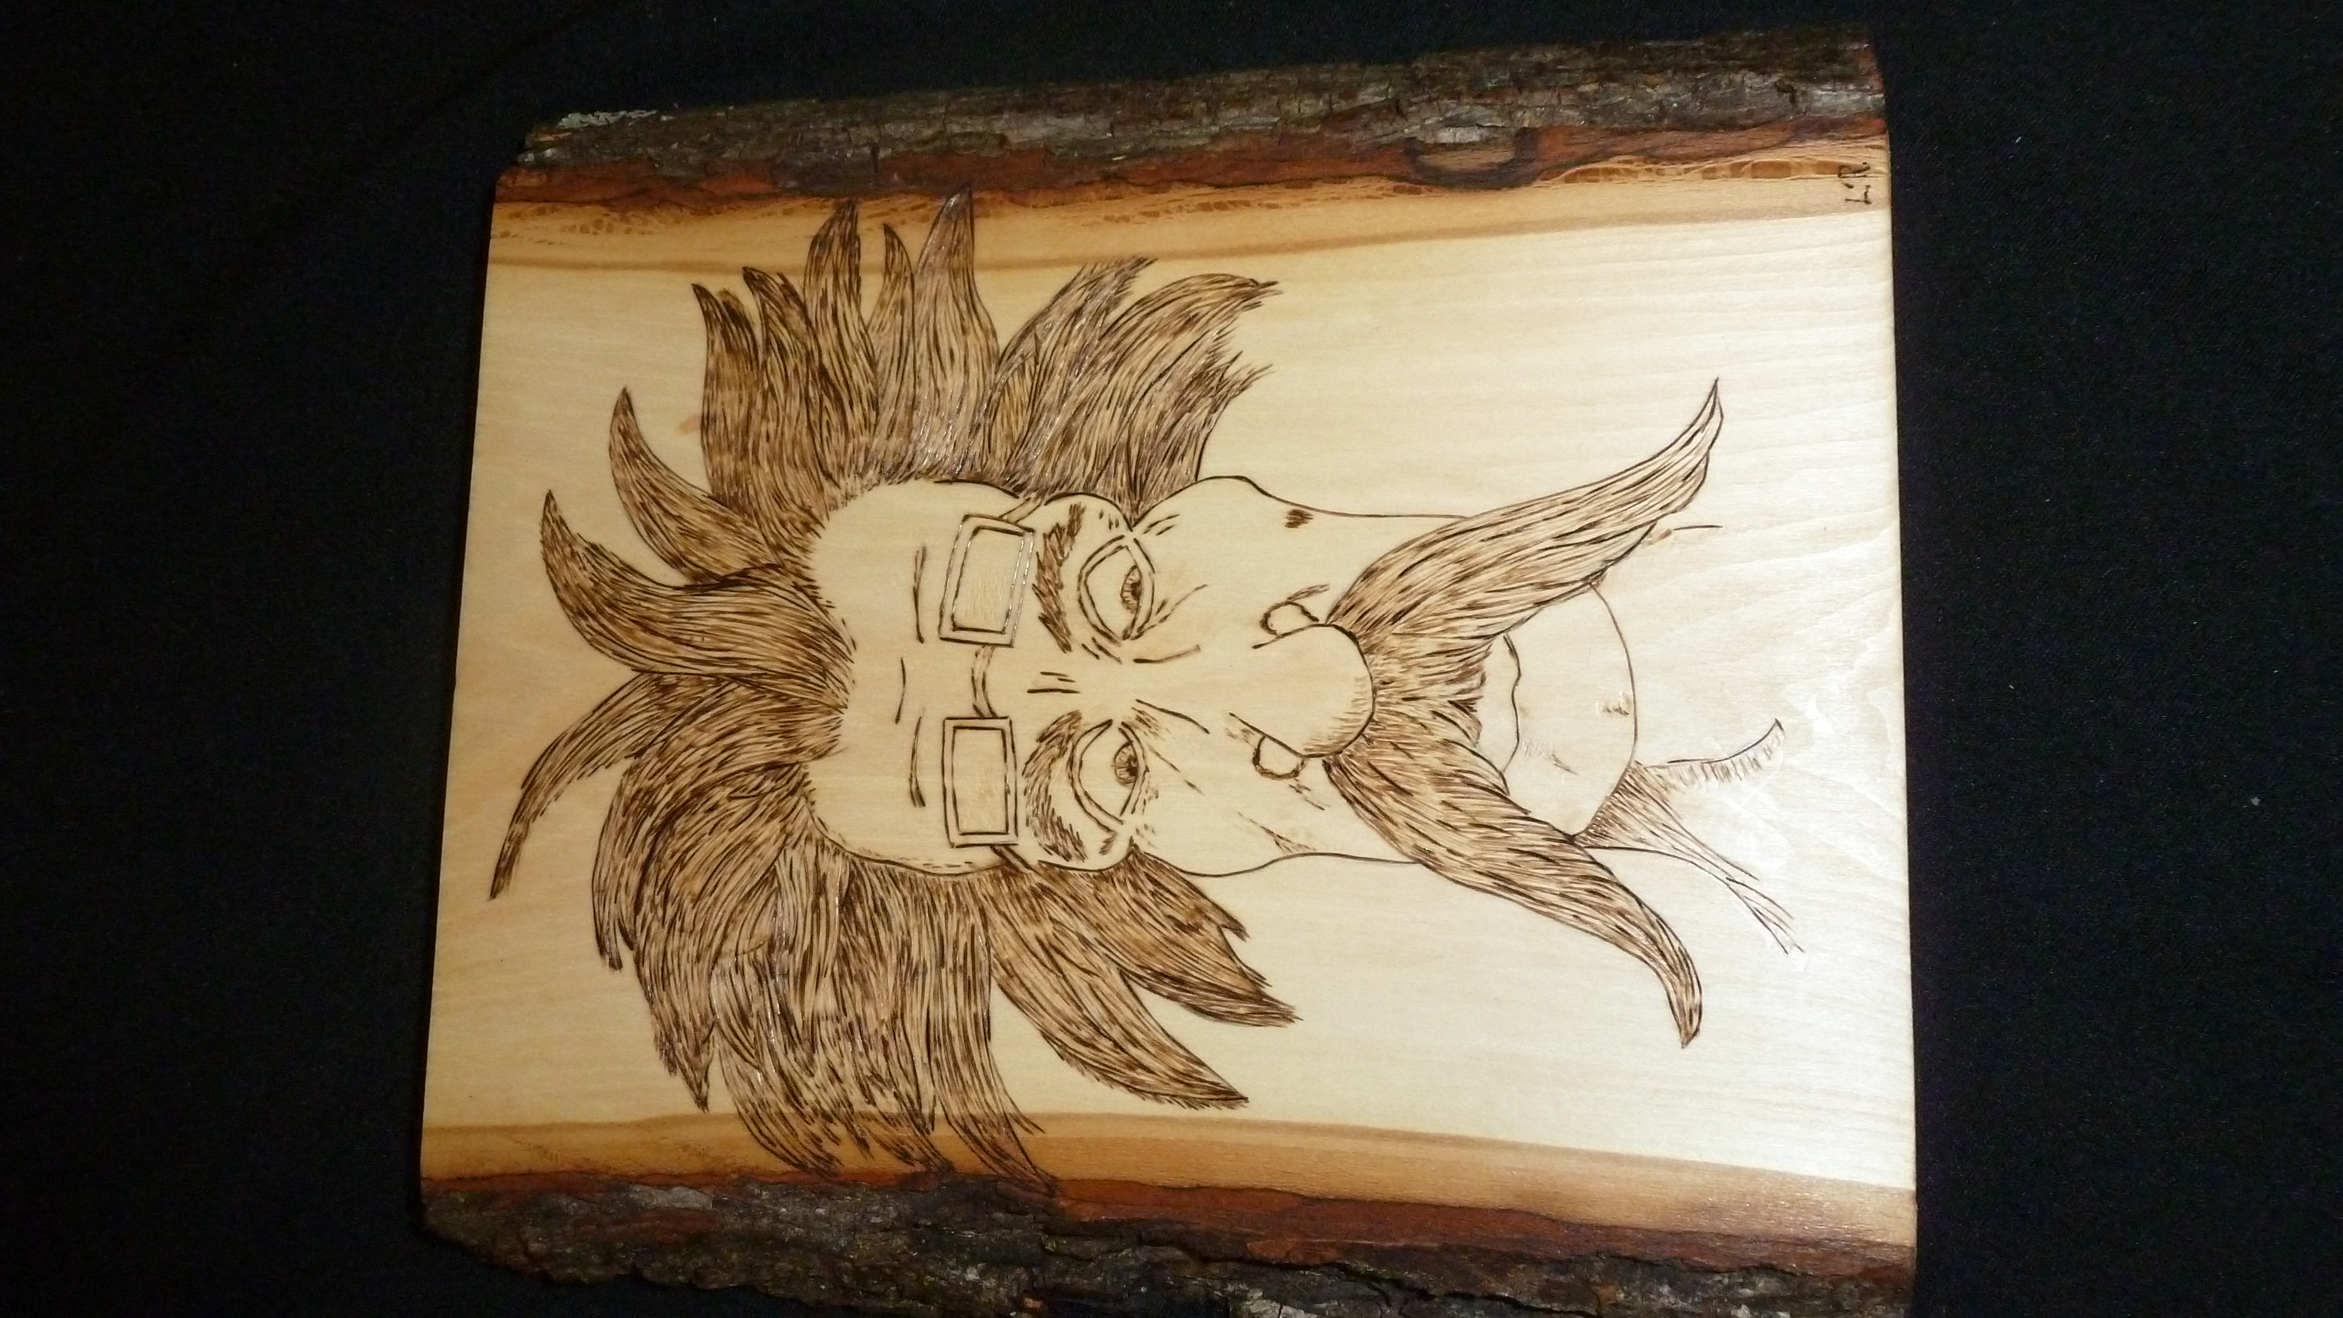
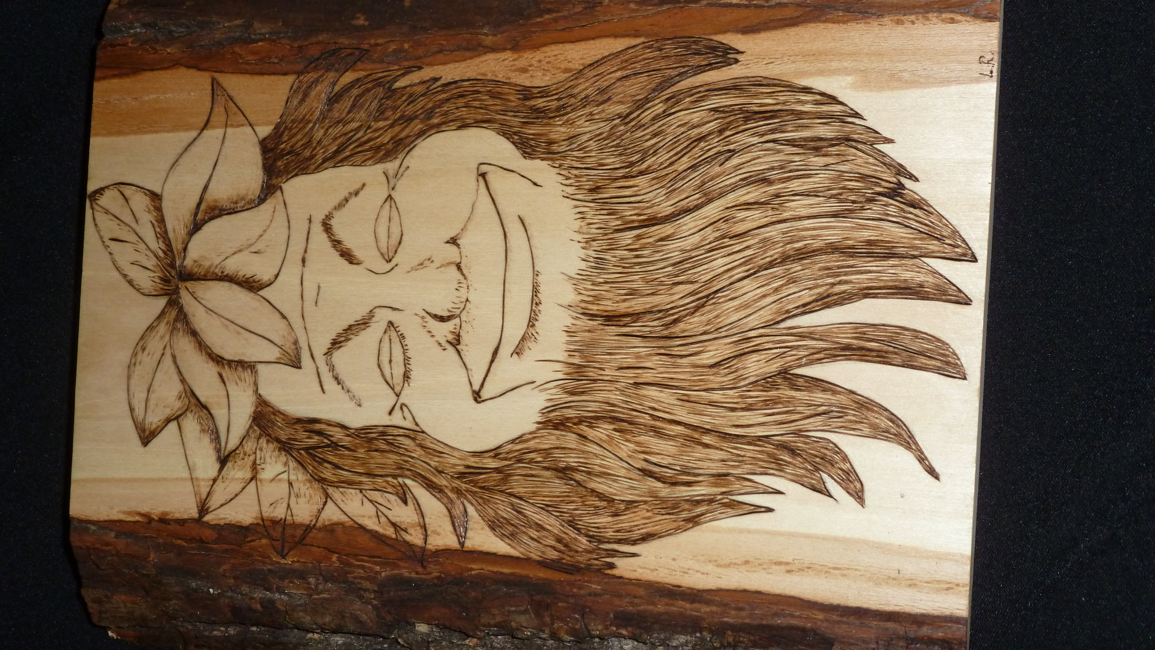

details will follow after registration.
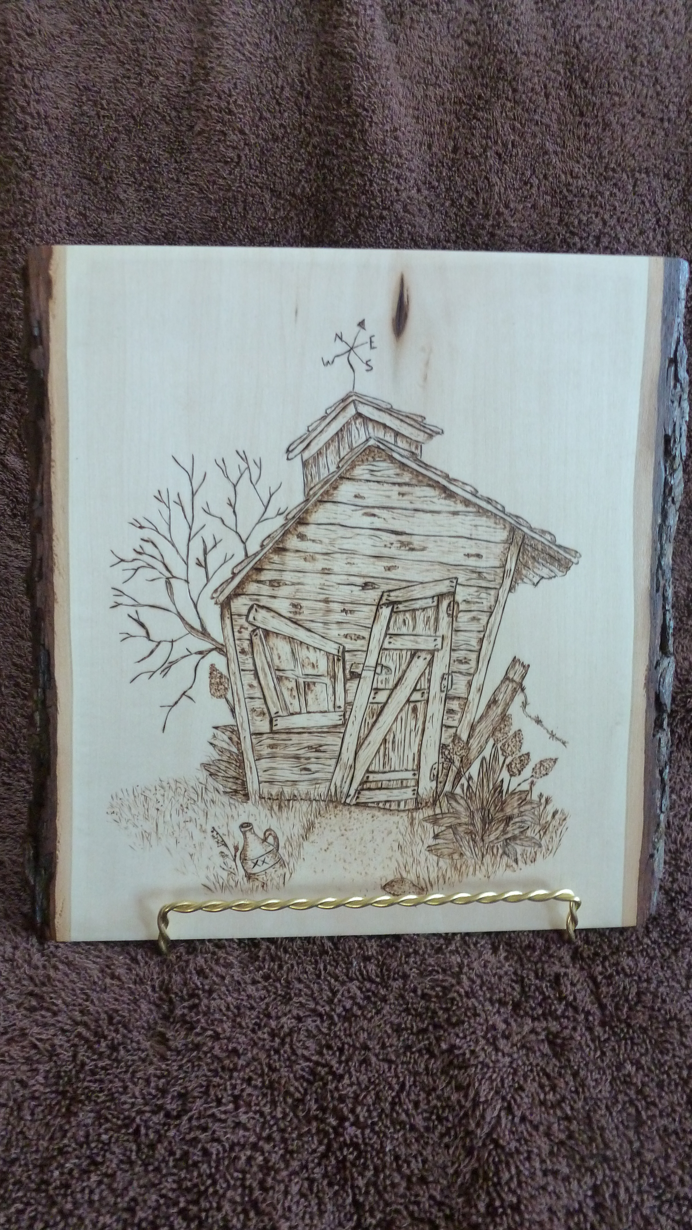

# | Your Name, contact info: | Fee
 | Workshop Name(s) (please indicate)  Wood burning (Pyrography)  with Louise Reilly cost $30.00  Please make payment for this class to Prairie Canada Carvers.  Cost as indicated in workshop bulletin.  Register by mail. Send this form to:  Tom McCormack, 39 Brixford Cresc.. Winnipeg, MB, R2N 1E1  204-253-0885  Prompt registration for seminars is encouraged, as participation numbers are limited | _______.00
 | Total

